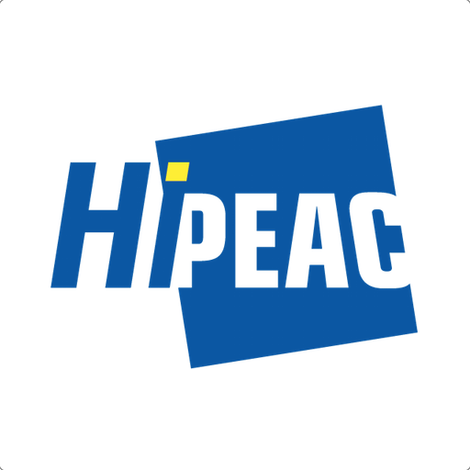

|  |  |
| --- | --- |
|  |  |

**COLLABORATION WORKSHOP**

**Advanced Computing and Cyber-Physical Systems 2016 Brussels, 14 June 2016**

*Hotel and Congress Centre Bedford, 135 Rue du Midi 1000 Brussels*

**The context:**

The “Components and Systems” directorate of DG Connect – European Commission supports the digitisation of European industry through policy actions and through research and innovation funding. The reference markets are mainly industrial (manufacturing, automotive, aerospace, safety critical applications) including also the traditional “low-tech” industries like agriculture or construction. In this context, research and innovation projects in the “Computing” and “CPS” areas are meant to contribute to two main pillars of the “Leadership in Digital Industry” strategy, which are (1) digital platforms for industry and (2) innovation hubs for the widespread adoption of digital technologies.

**The workshop:**

This Collaboration workshop will bring together the "Cyber-Physical Systems", "Advanced Computing" and the “Mixed Criticality Systems" project clusters financed by the European Commission under FP7 ICT Call 10 (2013), H2020 ICT Call 1 (2014) and Call 4 (2015).

The workshop will be held on **Tuesday 14 June** from 9.00 to 17.30 **at the Bedford hotel** **in Brussels** back to back with the Smart Anything Everywhere 2016 Event.It is organized by HiPEAC (<http://www.hipeac.net/>) in collaboration with the European Commission.

The objectives of the workshop are:

**Networking and synergies:**

Identify synergies and possibilities for cooperation between projects/participants, either within the context of the project or for exploitation of results; allowing partners in different projects to meet each other and being aware of what is going on.

**Assessment and best practices:**

Better overall understanding, for both Commission staff and project partners, of what is happening in this area of research and innovation, with possibility for PO and project partners to informally assess the global progress. Identification and exchange of **best practices**, especially in the areas **of standardization, exploitation, platform and ecosystem building**.

**Future plans:**

Projects will have the opportunity to explain the most promising areas of research and innovation they foresee. Commission staff will discuss the overall strategy of European Commission in digital technologies, the overall directions for the next workprogramme, and the forthcoming funding opportunities including other instruments for supporting innovation e.g. in the context of the “innovation radar”. The concepts of digital platform and ecosystem building will be explained in detail.

The workshop will be held back-to-back with the Smart Anything Everywhere 2016 Event (SAE 2016) that will explore the progress achieved by the SAE initiative so far and the impact participation has had on SMEs. The concept of the initiative to facilitate access to SMEs and midcaps to latest technologies in the areas of systems and components and first results will be presented together with best practices and lessons learnt. The future of the initiative will be discussed and the corresponding forthcoming call ICT-4-2017 "Smart Anything Everywhere Initiative" will be presented.

**Draft agenda:**

08:30 – 09:00 Registration and welcome coffee

**EC Introduction**

09:00 – 09:15 Introduction, aim of the workshop (European Commission)

09:15 – 09:25 The Innovation Radar: what can the EC do for your project? (EC)

09:25 – 09:35 IPR management: what can the JRC do for your project (EC)  
GUTT-MOSTOWY Karolina (JRC) tbc

**Projects Pitches** (1'30'' highlight per project)

**Next gen servers**

09:35 – 09:45 EUROSERVER, M2DC, UNISERVER, OPERA, DREDBOX

09:45 – 09:50 Q&As

**Exploiting Synergies from advanced computing and CPS**

09:50 – 10:00 Heterogeneous computing: ADEPT, REPARA, SAVE, NANOSTREAMS

10:00 – 10:10 Realtime / Reliability: P-SOCRATES, HARPA, CLERECO, EXCESS

10:10 – 10:20 Cloud / HPC: DREAMCLOUD, FIPS, POLCA

10:20 – 10:30 New Cross-layer programming: TANGO, ARGO, PHANTOM

10:30 – 10:40 Q&As

**Systems of systems**

10:40 – 10:45 AMADEOS, DYMASOS, LOCAL4GLOBAL

10:45 – 10:50 Q&As

10:50 – 11:20 *Coffee and networking*

**Modelling, toolchains and methods for smart CPS**

11:20 – 11:35 COSSIM, U-TEST, SAFURE, IMMORTAL,   
UNCOVERCPS, AXIOM, TAPPS, INTOCPS

11:35 – 11:40 Q&As

**Mixed-criticalities**

11:40 – 11:45 DREAMS, PROXIMA, CONTREX

11:45 – 11:50 Q&As

**Towards platform and ecosystems**

11:50 – 12:05 EoT, CP-SETI, HERCULES,

LPGPU2, SAFEPOWER, TULIPP

12:05 – 12:10 Q&As

**Connection innovators across value chains**

12:10 – 12:20 Main findings of SAE 2016 event

12:20 – 12:30 TETRACOM, EUROCPS, CPSELABS

12:30 – 12:40 Q&As

**Road mapping and community building**

12:40 – 12:55 HIPEAC, CYPHERS, CPSOS,   
ROAD2CPS, TAMS4CPS, CPS-SUMMIT

12:55 – 13:00 Q&As

13:00 – 13:50 *Lunch and networking*

13:50 – 14:05 platforms and ecosystems building (EC, Max Lemke)  
14:05 – 14:10 Sneak preview ICT-5-2017: Customised and low-energy computing (EC)

14:10 – 15:40 4 Breakout sessions to share best practices and lessons learnt on

1. Architectures

2. Programming

3. Modelling

4. Ecosystems and Interoperability

*Projects to cluster mixing the 3 calls (FP7 ICT-10- 2013, H2020 ICT-01-2014, H2020 ICT-04-2015)*

*1 coordinator per session responsible for running the session and producing a short session report.*

15:40 – 16:00 *Coffee and networking*

16:00 – 16:15 Plenary conclusions from the 4 breakout sessions

16:15 – 16:30 Directions for next work programme WP2018-2019 & WP2020 (EC)

16:30 – 17:10 Discussion of future plans, emerging topics and directions

17:10 – 17:15 Wrap-up (EC)

**Outcome of the workshop**

1. A short high level report presenting the achievements and impact of the cluster in a journalistic style for the layperson including a short presentation of the most promising exploitation plans (new products and services, development of existing products, spin-offs, growing SMEs …).

2. A workshop report presenting the achievements of all the projects.

3. A report on the discussion of future plans, emerging topics and directions.

**Contacts:**

Marc Duranton, HiPEAC vision coordinator, [marc.duranton@cea.fr](mailto:marc.duranton@cea.fr)

Jerome DETHIER, European Commission, CONNECT, Complex Systems and Advanced Computing, [jerome.dethier@ec.europa.eu](mailto:jerome.dethier@ec.europa.eu)

Sandro D'Elia, European Commission, CONNECT, Complex Systems and Advanced Computing, [Sandro.delia@ec.europa.eu](mailto:Sandro.delia@ec.europa.eu)