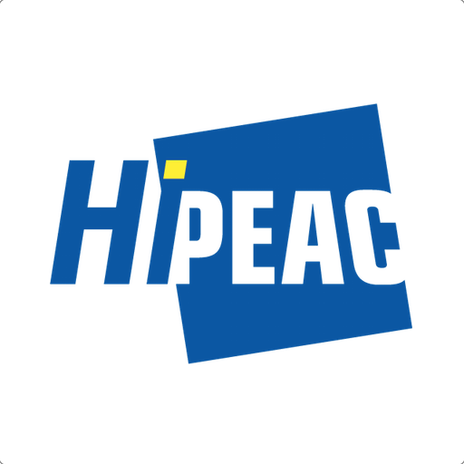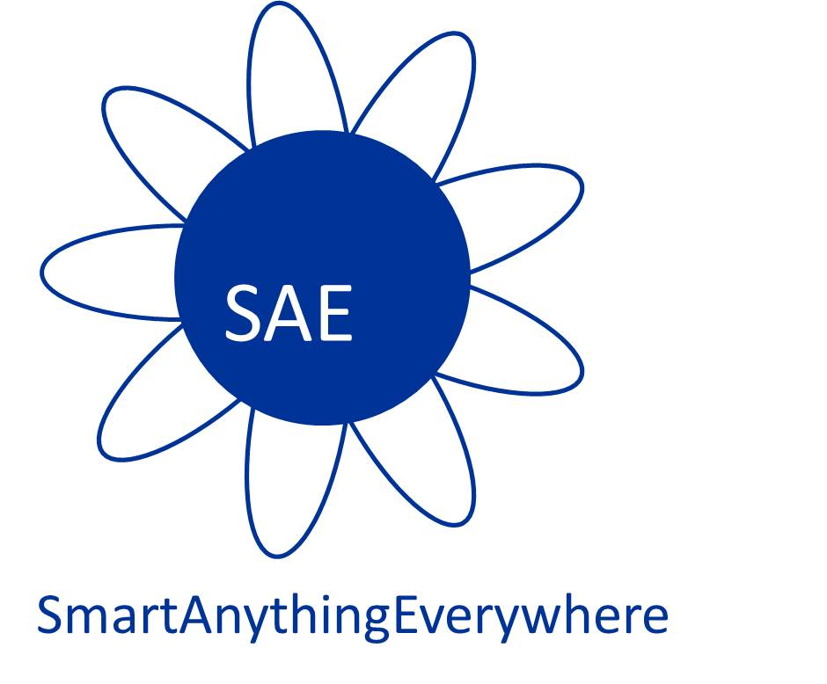



**WORKSHOP**

**Smart Anything Everywhere 2016:   
Enhancing digital transformation in European SMEs'**

**Brussels, 13 June 2016**

*Hotel and Congress Centre Bedford, 135 Rue du Midi 1000 Brussels*

**Introduction:**

Digital technologies transform entire business sectors with major impacts on the labour market and the society at large. Ahead of us are challenges and opportunities to be seized. We fully embrace these changes and aim to further build a stronger digital economy and society. Digital technologies not only transform the high-tech sector: they are disruptive for the industry at large, high-tech and low-tech industry alike.

Starting in FP7 and more broadly applied in Horizon 2020, the European Commission is supporting a group of innovation initiatives supporting SMEs and mid-caps across the economy in digital value creation. The formula for success is the collaboration of industrial actors across the complete value chain in a large number of small experiments facilitated by Europe's leading competence centres. By going broad both in terms of applications and in terms of actors (e.g. SMEs and mid-caps both on the provider and the user side), this scheme is important for the strategy for Digitising European Industry. Major initiatives are "ICT Innovation for Manufacturing SMEs" (I4MS), supporting largely process innovation, and "Smart Anything Everywhere" (SAE), supporting product and service innovation.

The SAE initiative is centered around networks of digital competence centres, usually research technology organisations (RTOs) or technology transfer-oriented university institutes that cluster a wide spectrum of technical and application knowledge to support digital innovation. SAE innovation hubs gives SMEs and mid-cap companies the opportunity to experiment with new digital technologies, try them out in their processes and work together with the suppliers of the technology to adapt it to their specific needs.

To date, a first set of six projects (funded through FP7 Integration Projects and Horizon 2020 Innovation Actions) made available 40M€ to support more than 150 experiments. The aim is to involve more than 200 SMEs and midcaps in the field of Cyber-Physical Systems (CPS), Internet of Things (IoT), Smart Systems Integration (SSI), Electronic Components and Systems (ECS), advanced computing or Organic and large area electronics (TOLAE). Many of the existing experiments are very successful. The aim of the forthcoming call SAE 2017 is to take this further through additional projects supported by a budget of approximately EUR 25 M€.

**DRAFT AGENDA:**

09:00 – 09:30 Registration

09:30 – 10:00 SAE and the digitisation of European industry *Max Lemke (EC)*

**Innovation Hubs delivering results**

10:00 – 10:10 CPSELABS achievements *Holger Pfeifer (Fortiss, DE)*

10:10 – 10:20 A fast-track experiment tbd

10:20 – 10:30 EUROCPS achievements *Olivier Thomas (CEA, FR)*

10:30 – 10:40 An Industrial experiment tbd

10:40 – 10:50 GATEONE achievements *Régis Hamelin (Blumorpho, FR)*

10:50 – 11:00 An SME experiment tbd

11:00 – 11:30 *Coffee break*

11:30 – 11:40 SMARTER-SI achievements *Rainer Günzler (Hahn-Schickard, DE)*

11:40 – 11:50 An SME experiment tbd

11:50 – 12:00 TETRACOM achievements *Rainer Leupers (RWTH, DE)*

12:00 – 12:10 A Technology Transfer Project tbd

12:10 – 12:20 COLAE achievements Ilkka Kaisto (VTT, FI) tbc

**Innovation Hubs best practices and lessons learnt**

12:20 – 13:00 **Panel discussion** on best practices and lessons learnt

*Rainer Leupers (RWTH, DE), Holger Pfeifer (Fortiss, DE),   
Olivier Thomas (CEA, FR), Régis Hamelin (Blumorpho, FR),*

*Rainer Günzler (Hahn-Schickard, DE),* Ilkka Kaisto (VTT, FI)

*Moderator: *Willy Van Puymbroeck (EC)*

13:00 – 14:00 *Networking lunch*

**H2020 ICT-04-2017 Smart Anything Everywhere (SAE) call**

14:00 – 14:10 Overview of the call's objectives *Anne-Marie Sassen (EC)*

14:10 – 14:50 Innovation Actions (IAs):

Area 1 : Cyber-Physical Systems (CPS) *Jerome Dethier (EC)*

Area 2 : Customised low power energy   
 computing powering CPS and the IoT *Jerome Dethier (EC)*

Area 3 : Advanced micro-electronics components   
 and Smart Systems Integration *Oana Radu (EC)*

Area 4 : Organic and large area electronics (TOLAE) *P. Reynaerts (EC)*

14:50 – 15:00 Coordination and Support Actions (CSA) *Oana Radu (EC)*

**Outlook for the future of the SAE initiative**

15:00 – 15:45 **Panel discussion**

How to root SAE in the regional and national initiatives ?

How can industry from other regions participate?

Do we need a scheme of associated innovation hubs?

*Moderator*: Max Lemke* *(EC)*

15:45 – 16:15 *Coffee break*

16:15 – 17:15 Discussions on directions for the work programme 2018-2020

*Moderators*: Willy Van Puymbroeck, Ronan Burgess & Max Lemke* *(EC)*

17:15 End of event

**The context:**

The “Components and Systems” directorate of DG Connect – European Commission supports the digitisation of European industry through policy actions and through research and innovation funding. The reference markets are mainly industrial (manufacturing, automotive, aerospace, safety critical applications) including also the traditional “low-tech” industries like agriculture or construction. The Innovation Actions of the SAE initiative are meant to contribute to the Digital Innovation Hubs pillar of the “Digitising European Industry” strategy for the widespread adoption of digital technologies in the areas of Cyber-Physical Systems (CPS), Customised Computing, Smart Systems Integration (SSI) and Organic & Large Area Electronics (TOLAE).

**The workshop:**

This public workshop will bring together high-level speakers from the European Commission and relevant industries, competence centres, and key players in European digital technologies to share ideas on topics related to the reindustrialisation of Europe and the key role played by SMEs.

The workshop will explore the progress achieved so far by the SAE initiative and the impact participation has had on SMEs. The concept of the initiative to facilitate access to SMEs and midcaps to latest technologies in the areas of systems and components and first results will be presented together with best practices and lessons learnt. The future of the initiative will be discussed and the corresponding forthcoming call ICT-4-2017 "Smart Anything Everywhere Initiative" will be presented. Additionally, there will be a discussion on how to continue this scheme under workprogramme 2018-2020.

The workshop will bring the ongoing innovation projects on “Advanced Computing", "CPS", "SSI" and “TOLAE" together with the actors in Europe such as SMEs, RTOs or industries interested in future collaboration to further develop the SAE ecosystem. The projects financed by the European Commission under FP7 ICT 2011 Call 7 (COLAE), ICT 2013 Call 10 (TETRACOM) and H2020 ICT Call 1 2014 (SMARTER-SI, GATEONE, CPSELABS, EUROCPS) will present their first results, discuss lessons learnt and best practices.

The workshop programme will cover the main aspects of the initiative, the experience of the participating companies, and some of the experiments and applications developed under the initiative. SMEs will have the opportunity to interact with the main actors within the SAE community and will be informed on how their company can benefit from the initiative.

The workshop will be held on **Monday 13 June** from 9.00 to 17.30 **at the Bedford hotel in Brussels** (tbc) back to back with the Collaboration Workshop on Computing and Cyber-Physical Systems.It is organized by HiPEAC (<http://www.hipeac.net/>) in collaboration with the European Commission.

**The objectives of the workshop are:**

**Presentation and best practices of ongoing innovation actions:**

Presentation of the first results of the ongoing innovation actions to take stock of the progress achieved so far, to share best practices and to discuss lessons learnt.

**Presentation of the forthcoming H2020 call on Smart Anything Everywhere ICT-04-2017:**

Inform the participants about the H2020 call on the SAE initiative by presenting the four focus areas of technologies:

i) Cyber-physical and embedded systems

ii) Customised low energy computing powering CPS and the IoT

iii) Advanced micro-electronics components and smart systems integration

iv) Organic and large area electronics

Additionally, the cascade funding to third parties scheme will be clarified.

**Discussion of future plans for the Work Programme 2018-2020 :**

In the light of lessons learnt so far with SAE, participants can discuss with EC staff possible directions for SAE innovation actions during WP 2018-2020.

**Networking and synergies:**

Allow participants to meet each other, to present their proposal ideas and to identify synergies and opportunities for cooperation between participants for the forthcoming call ICT-04-2016.

**Contacts:**

Jerome DETHIER, European Commission, CONNECT, Complex Systems and Advanced Computing, [jerome.dethier@ec.europa.eu](mailto:jerome.dethier@ec.europa.eu)

Oana RADU, European Commission, CONNECT, Components, [oana.radu@ec.europa.eu](mailto:oana.radu@ec.europa.eu)

Marc Duranton, HiPEAC vision coordinator, [marc.duranton@cea.fr](mailto:marc.duranton@cea.fr)